1. **Differences between ELB, ALB, and NLB. Where will you use which one?**

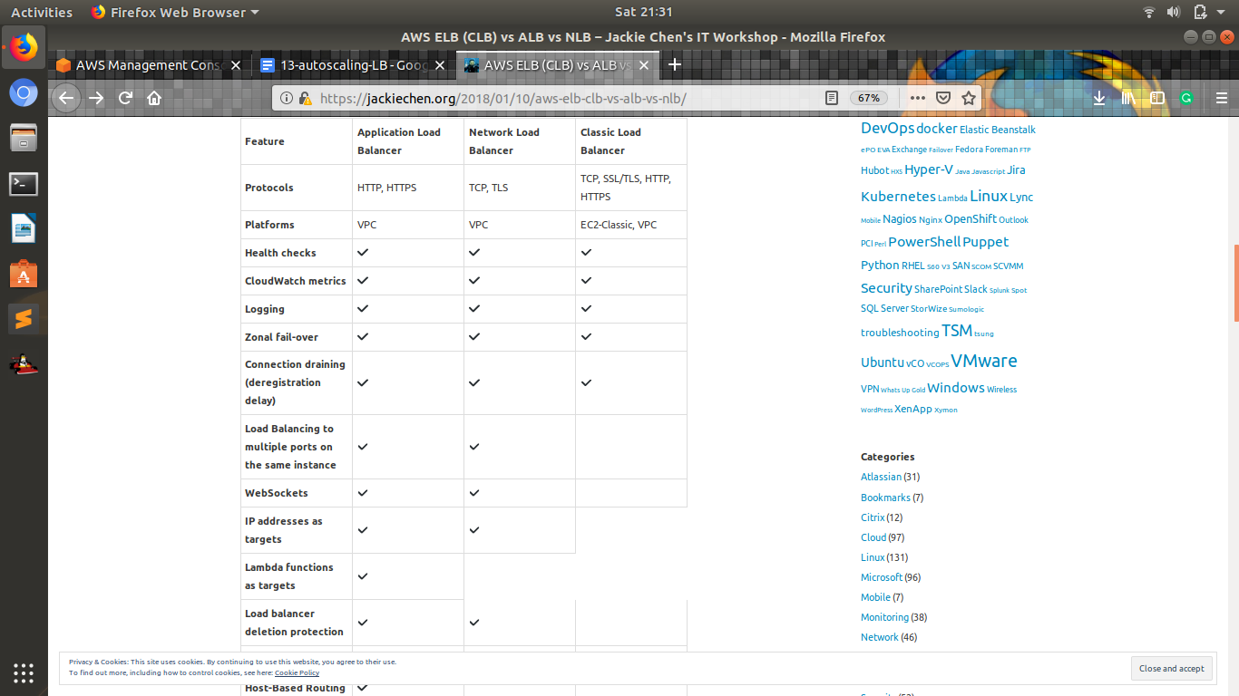

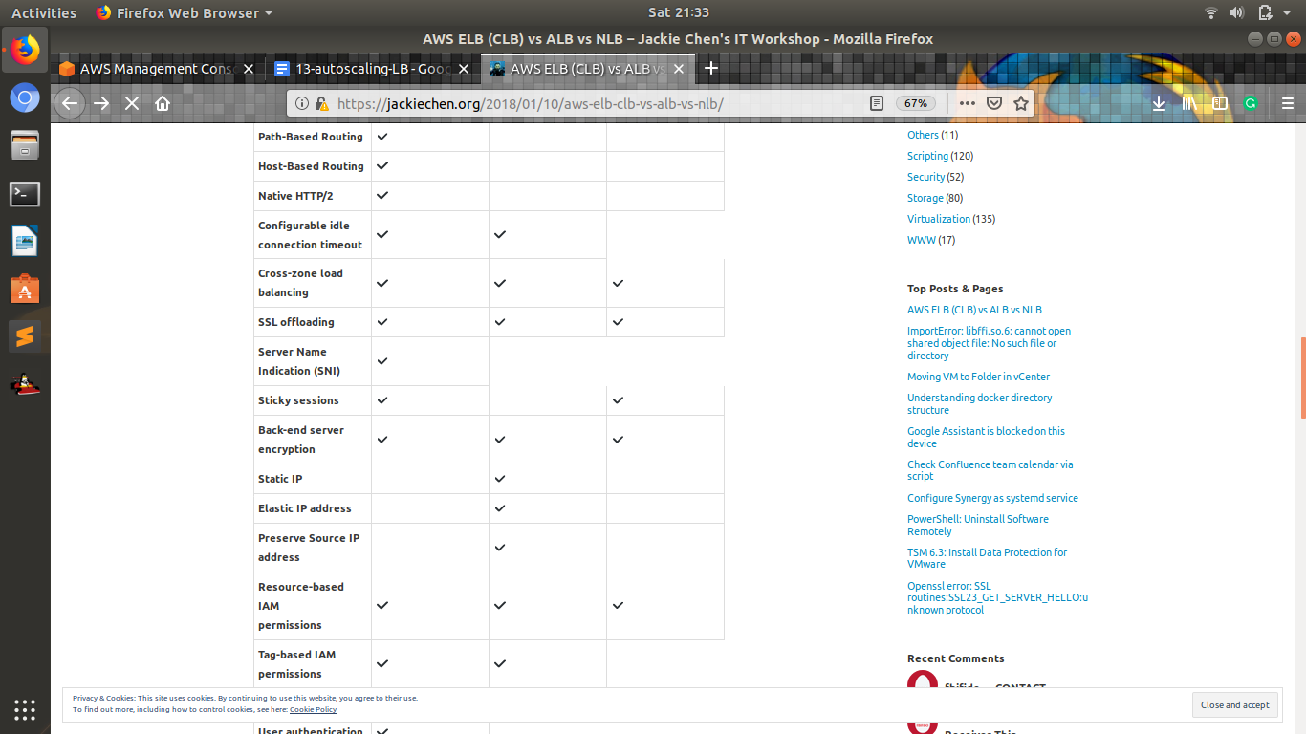

**The Classic ELB: An AWS Original**

The Classic ELB is a simple load balancer, is easy to configure, and given its longer history as a product, most AWS engineers are familiar with the product and have used it in the past. If your environment consists of clearly defined services which can each be mapped to a specific address, then the Classic ELB is the logical choice.

Like the more advanced ALB, the Classic ELB supports:

* SSL Termination
* Sticky Sessions
* Termination of Idle Sessions
* Completion of Requests to Instances In The Process Of Being Marked Unhealthy.

**The ALB: Perfect for Content-Based Routing**

As organizations move towards microservice architecture or adopt a container-based infrastructure, the ability to merely map a single address to a specific service becomes more complicated and harder to maintain.

In addition to the common features mentioned above (i.e. SSL Termination, Sticky Sessions, etc.), the ALB manages routing based on user-defined rules. A request to a URL which resolves to a single ALB can in turn route traffic to different services based on either the host or the content of the path contained within that URL.

Let’s take a quick look at some of the additional functionality available to you after you’ve created your Application Load Balancer. If you log into your AWS console and navigate to the Load Balancer section of the EC2 home page, you’ll be able to create new and edit existing load balancers. If you click on an existing ALB, you’ll be shown a series of tabs with additional information and configuration for the load balancer.

Much like the Classic ELB, when you click on the **Listeners** tab, you’ll be able to add additional listeners and point them to different targets. Where the ALB differs is the link to **View/edit rules.**

1. **Differences between step scaling and target scaling.**

# **AWS Step Auto Scaling Policies**

**Amazon Web Services** has introduced **Step Autoscaling Policies** for the autoscaling of EC2 instances. These policies are much different from the Simple Autoscaling Policies which are being used till the date. The cooldown periods are not supported in the Step Scaling Policies. It let you define lower bound , upper bound for metric values and the amount by which to scale in or scale out the instances.

With step scaling, you choose scaling metrics and threshold values for the CloudWatch alarms that trigger the scaling process as well as define how your scalable target should be scaled when a threshold is in breach for a specified number of evaluation periods.

Step scaling policies increase or decrease the current capacity of a scalable target based on a set of scaling adjustments, known as *step adjustments*. The adjustments vary based on the size of the alarm breach.

After a scaling activity is started, the policy continues to respond to additional alarms, even while a scaling activity is in progress. Therefore, all alarms that are breached are evaluated by Application Auto Scaling as it receives the alarm messages.

If your scaling metric is a utilization metric that increases or decreases proportionally to the capacity of the scalable target, however, amazon recommends target scaling policies.

**Limits**

* You cannot create step scaling policies for DynamoDB tables and global secondary indexes.
* You can create 50 scaling policies per scalable target. This includes both step scaling policies and target tracking policies.
* You can create 20 step adjustments per scaling policy.

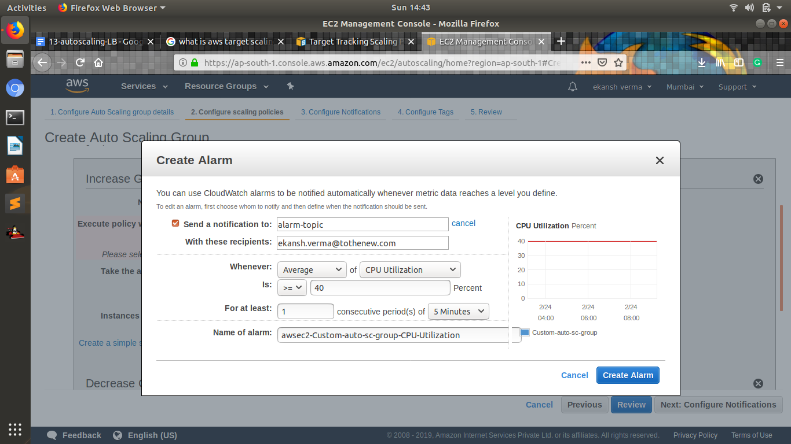



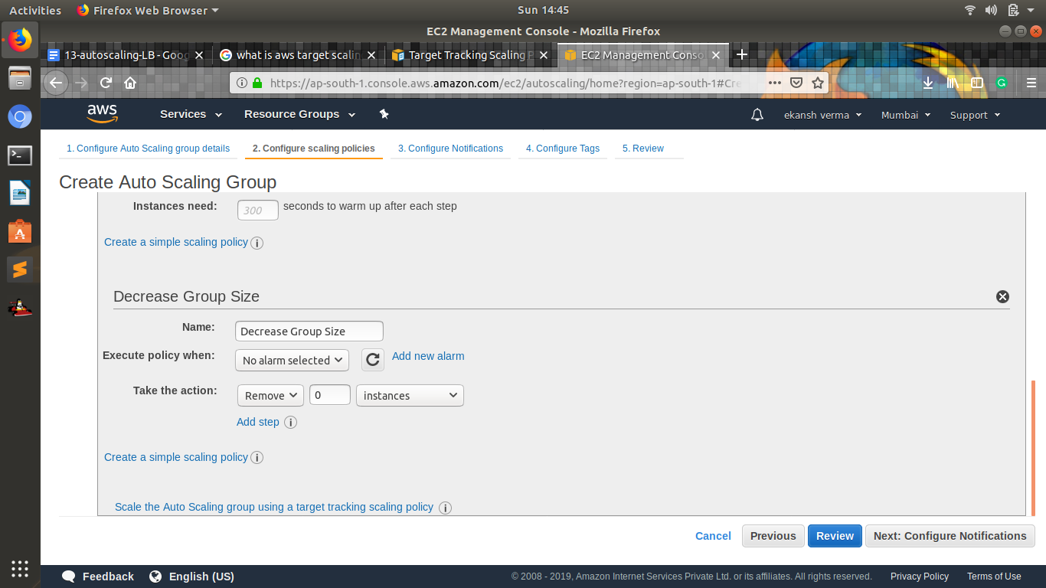

**Target Tracking Scaling Policies for Application Auto Scaling**

With target tracking scaling policies, you choose a scaling metric and set a target value. Application Auto Scaling creates and manages the CloudWatch alarms that trigger the scaling policy and calculates the scaling adjustment based on the metric and the target value. The scaling policy adds or removes capacity as required to keep the metric at, or close to, the specified target value. In addition to keeping the metric close to the target value, a target tracking scaling policy also adjusts to changes in the metric due to a changing load pattern.

You can have one or more target tracking scaling policies, one or more step scaling policies, or both. Application Auto Scaling scales based on the policy that provides the largest capacity for both scale in and scale out. This provides greater flexibility to cover multiple scenarios and ensures that there is always enough capacity to process your application workloads.

You can have multiple target tracking scaling policies for a scalable target, provided that each of them uses a different metric. The intention of Application Auto Scaling is to always prioritize availability, so its behavior differs depending on whether the target tracking policies are ready for scale out or scale in. It will scale out the scalable target if any of the target tracking policies are ready for scale out, and but will scale in only if all of the target tracking policies (with the scale-in portion enabled) are ready to scale in.

**Limits**

* You cannot create target tracking scaling policies for Amazon EMR clusters or AppStream 2.0 fleets.
* You can create 50 scaling policies per scalable target. This includes both step scaling policies and target tracking policies.

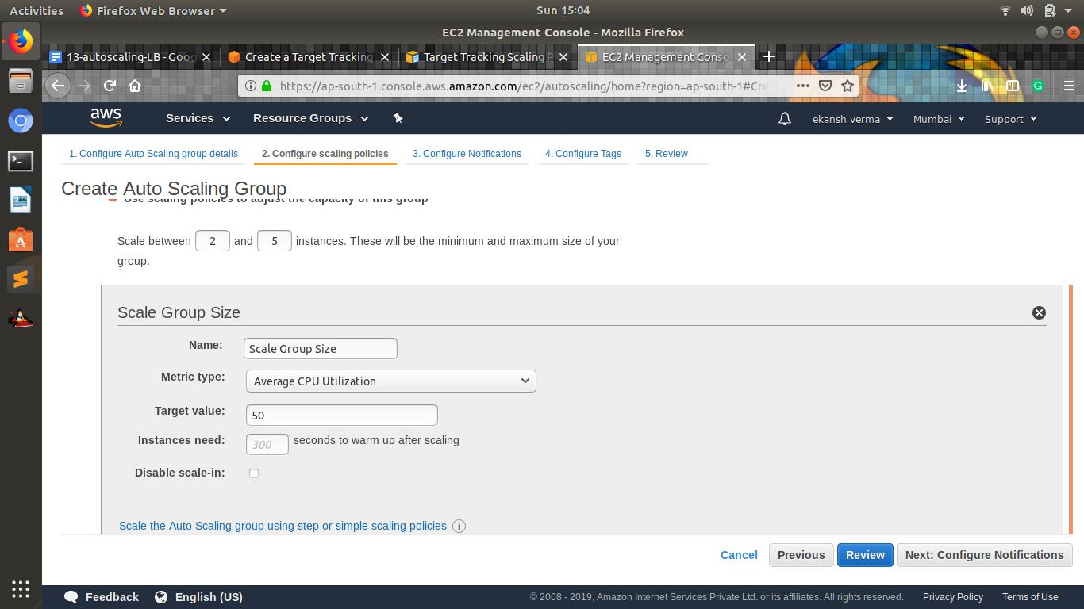

1. **Differences between Launch configuration and launch template.**

Replacing a Launch Configuration with a Launch Template

When you edit an Auto Scaling group that has an existing launch configuration, you have the option of replacing the launch configuration with a launch template. This lets you use launch templates with any Auto Scaling groups you currently use. In doing so, you can take advantage of the versioning and other features of launch templates.

After you replace the launch configuration for an Auto Scaling group, any new instances are launched using the new launch template, but existing instances are not affected.

Prerequisites:

Before you can replace a launch configuration in an Auto Scaling group, you must first create your launch template. The easiest way to create a launch template is to copy it from the launch configuration. For more information, see Copying a Launch Configuration to a Launch Template.

To replace the launch configuration for an Auto Scaling group:

* Open the Amazon EC2 console at https://console.aws.amazon.com/ec2/.
* In the navigation pane, choose Auto Scaling Groups.
* Select the Auto Scaling group and choose Details, Edit.
* For Launch Instances Using, choose the Launch Template option.
* For Launch Template, select your launch template.
* For Launch Template Version, select the launch template version, as needed. After you create versions of a launch template, you can choose whether the Auto Scaling group uses the default or the latest version of the launch template when scaling out.
* When you have finished, choose Save.

1. **Differences between EC2 healthcheck and load balancer health check**

**EC2 healthcheck**

Amazon EC2 Auto Scaling health checks use the results of the Amazon EC2 status checks to determine the health status of an instance. If the instance is in any state other than running or if the system status is impaired, Amazon EC2 Auto Scaling considers the instance to be unhealthy and launches a replacement instance. This includes when the instance has any of the following states:

* stopping
* stopped
* terminating
* terminated

If you attached a load balancer or target group to your Auto Scaling group, you can configure the group to mark an instance as unhealthy when Elastic Load Balancing reports it as OutOfService. If connection draining is enabled for your load balancer, Amazon EC2 Auto Scaling waits for in-flight requests to complete or the maximum timeout to expire, whichever comes first, before terminating instances due to a scaling event or health check replacement.

**Load balancer health check**

If you configure your Auto Scaling group to use the Elastic Load Balancing health checks, Amazon EC2 Auto Scaling determines the health status of the instances by checking both the EC2 status checks and the Elastic Load Balancing health checks.

This ensures that the group can determine an instance's health based on additional tests provided by the load balancer. The load balancer periodically sends pings, attempts connections, or sends requests to test the EC2 instances. These tests are called health checks.

If you configure the Auto Scaling group to use Elastic Load Balancing health checks, it considers the instance unhealthy if it fails either the EC2 status checks or the load balancer health checks. If you attach multiple load balancers to an Auto Scaling group, all of them must report that the instance is healthy in order for it to consider the instance healthy. If one load balancer reports an instance as unhealthy, the Auto Scaling group replaces the instance, even if other load balancers report it as healthy.

1. **Create 2 auto-scaling groups with** 
   1. **launch configuration**

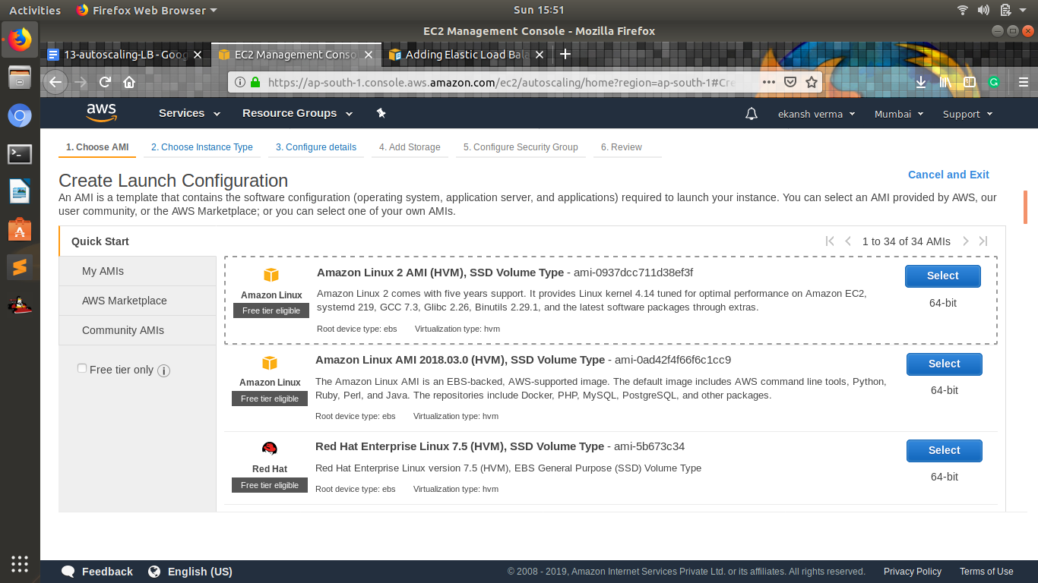

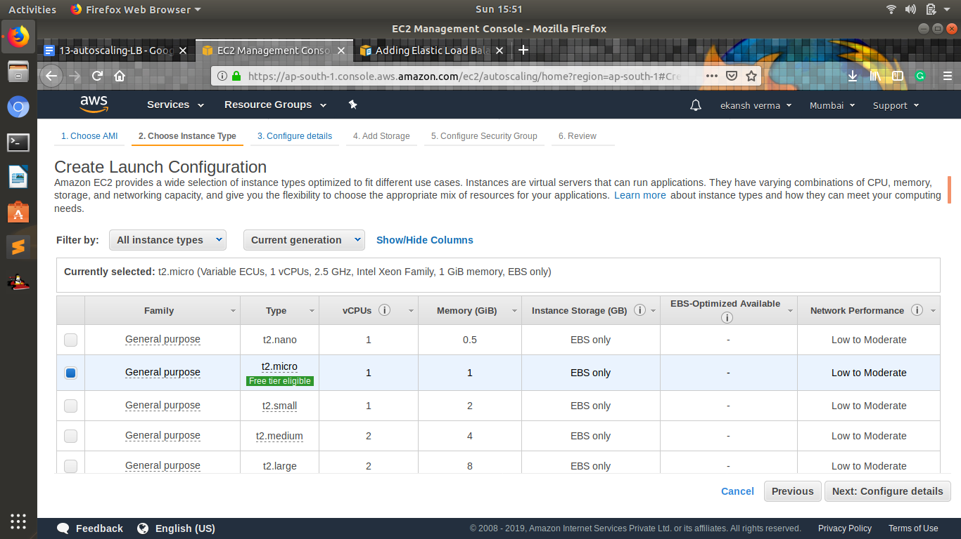

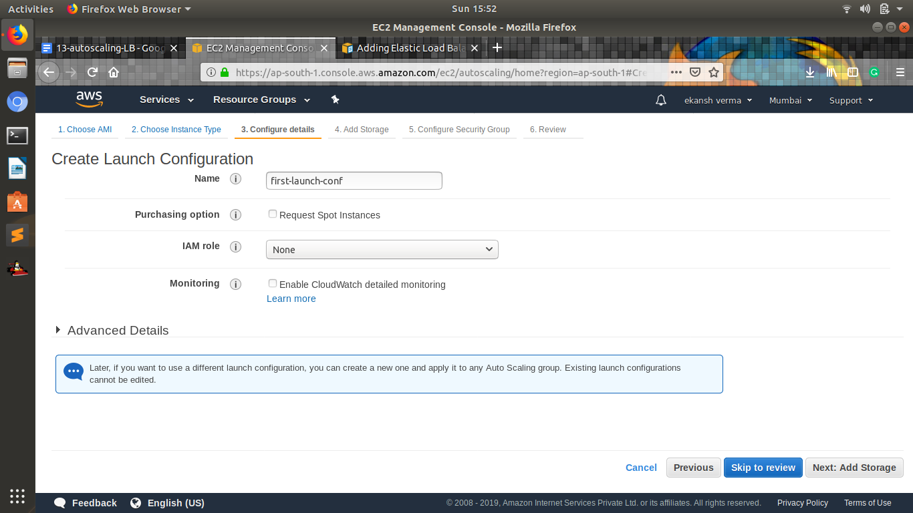

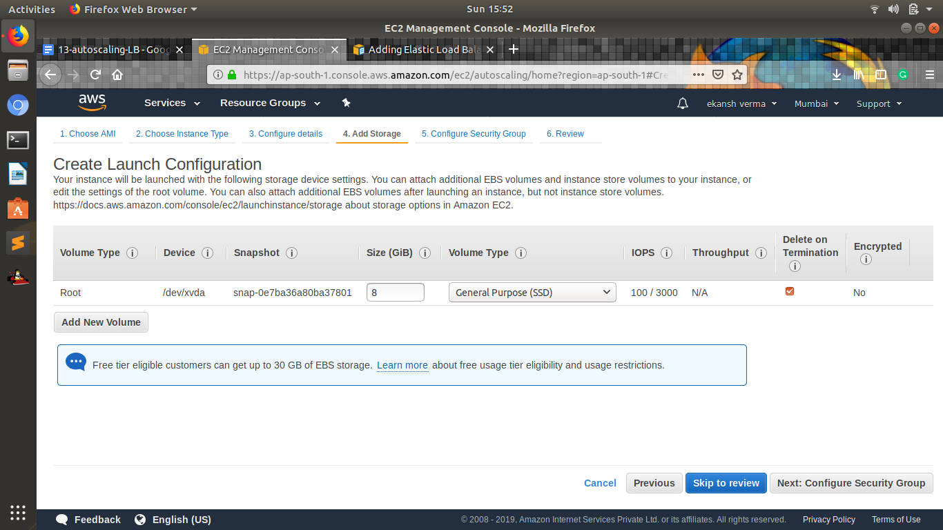

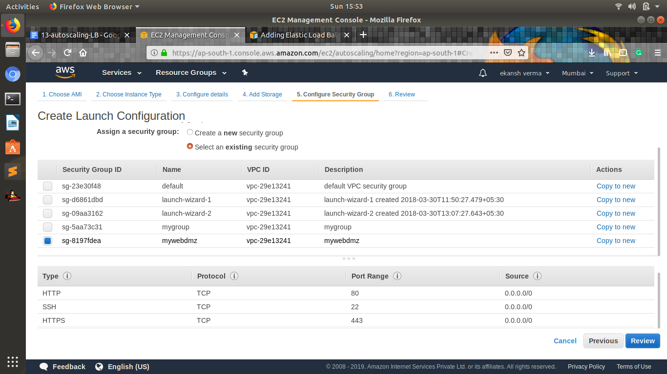

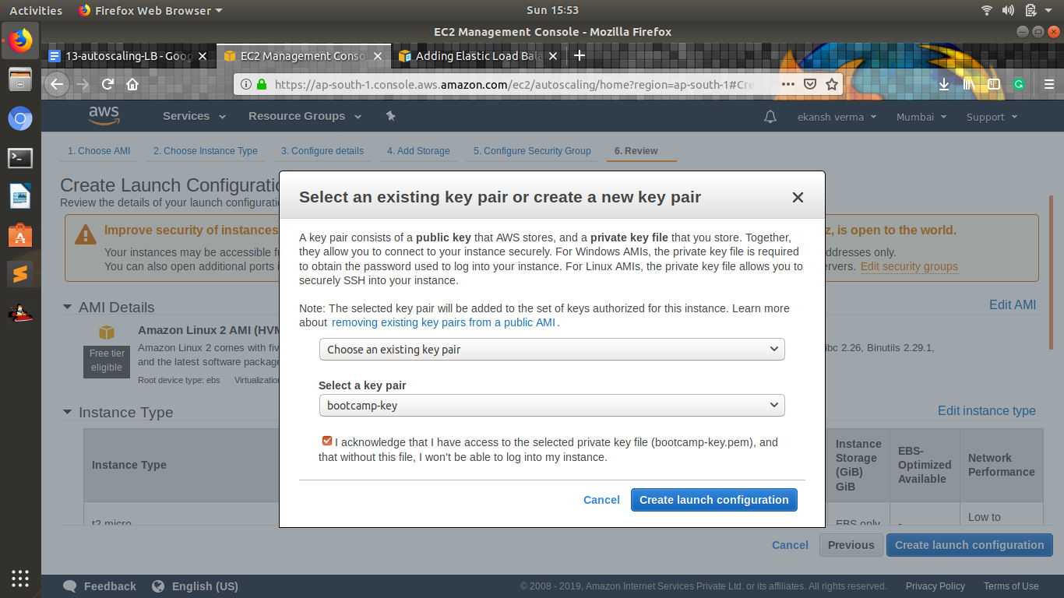

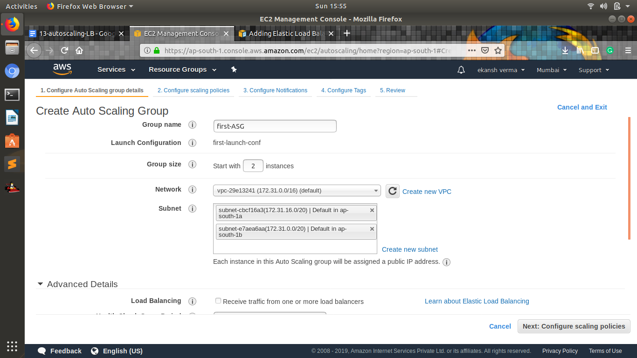

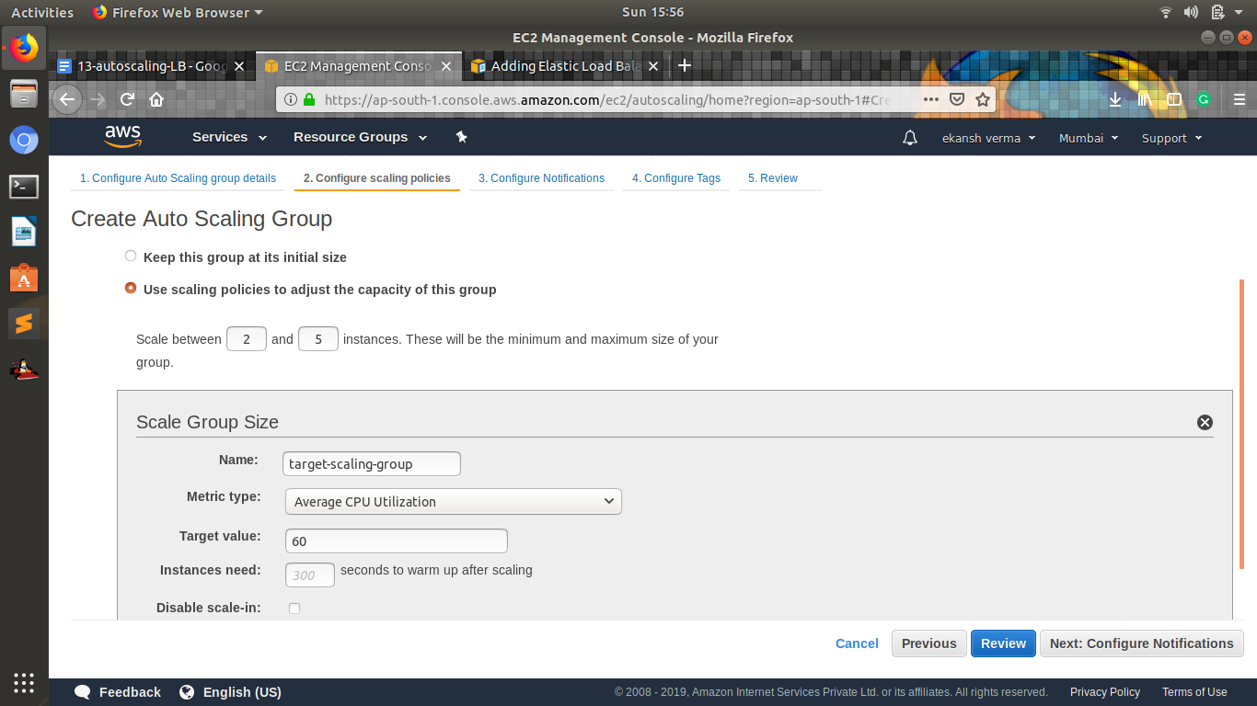

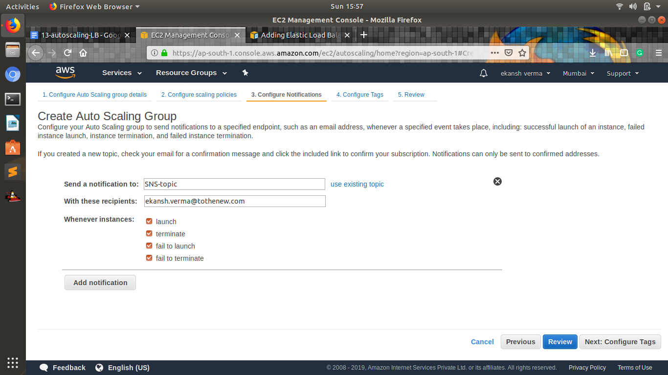

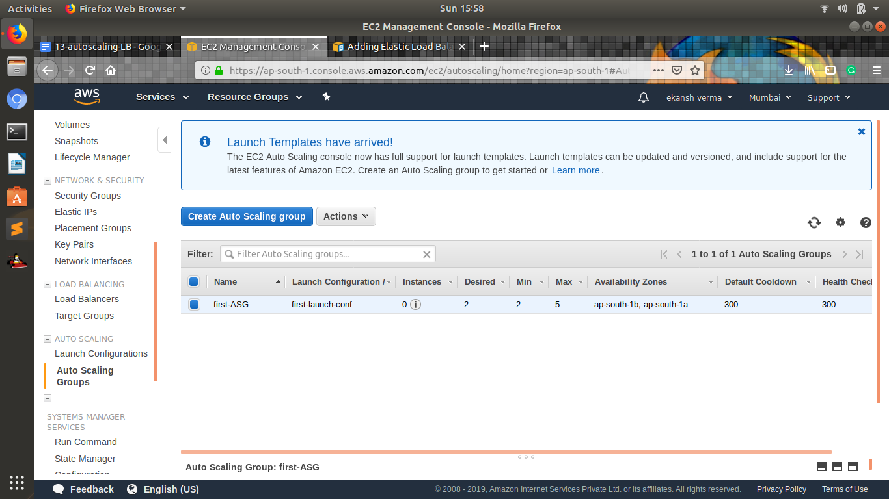

* 1. **launch template**

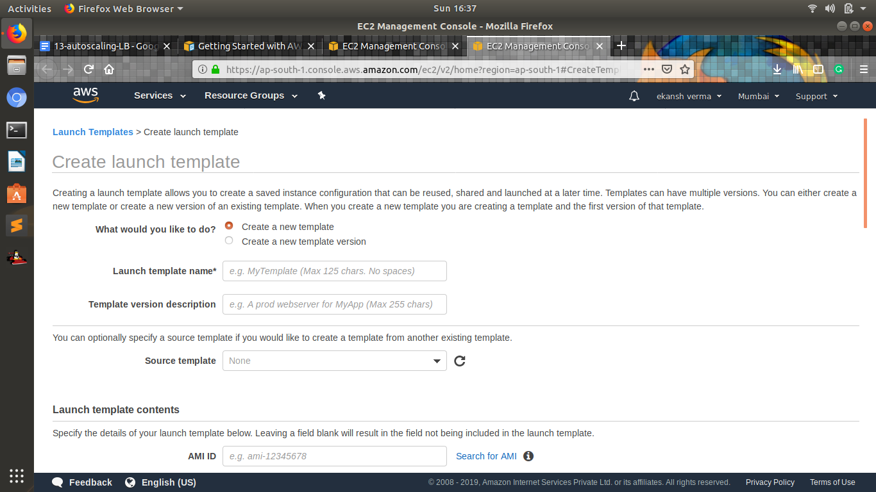

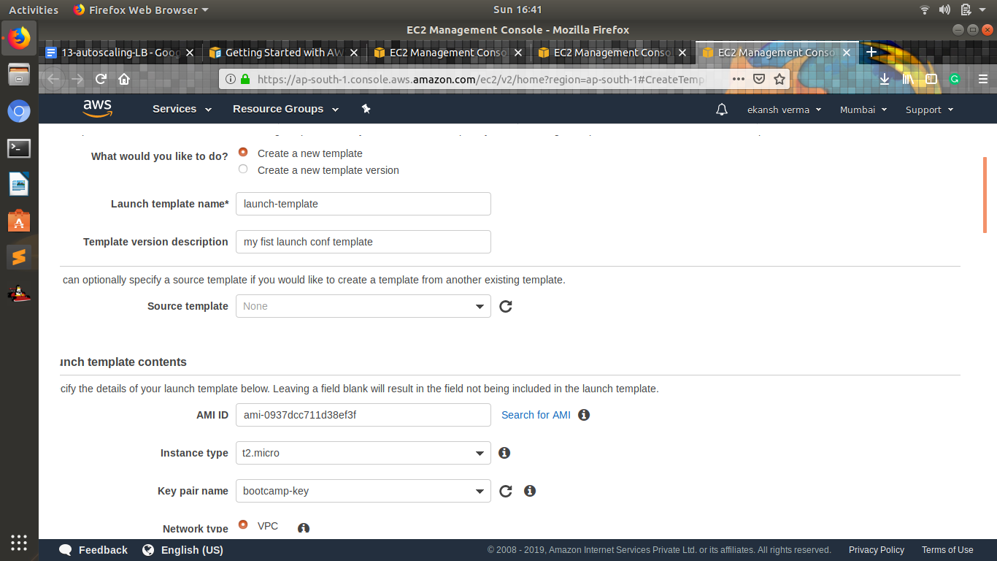

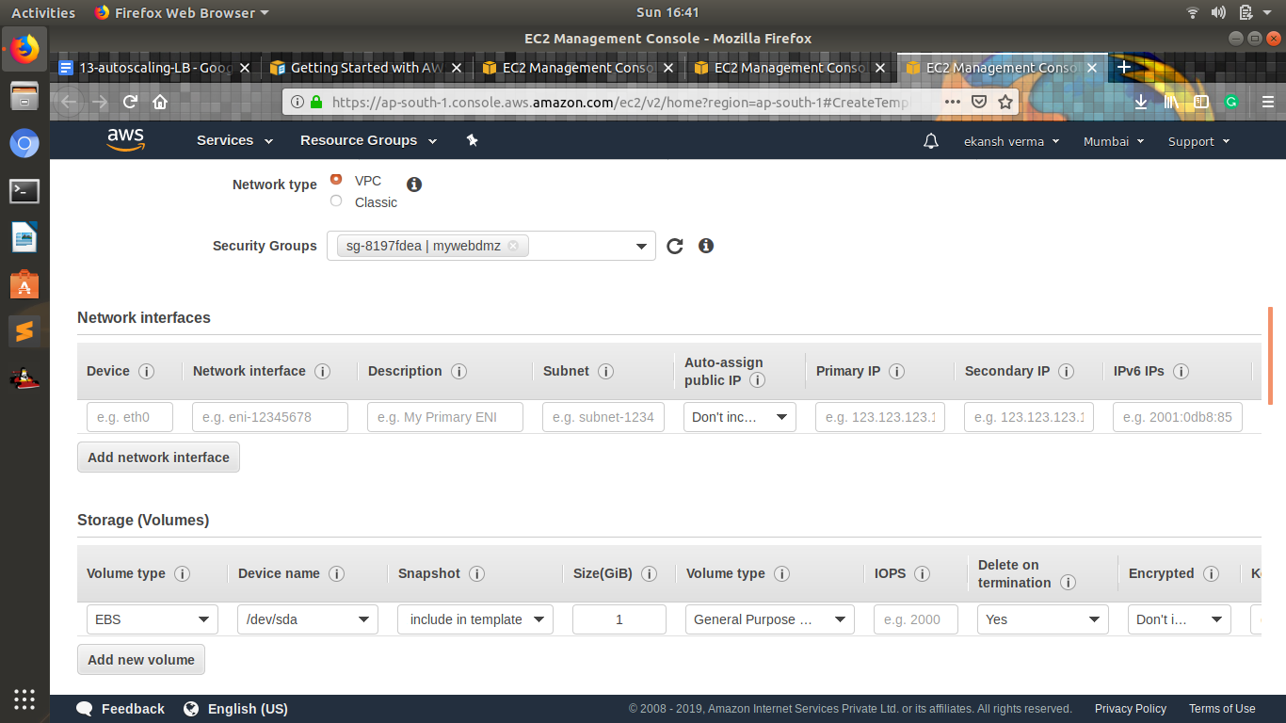

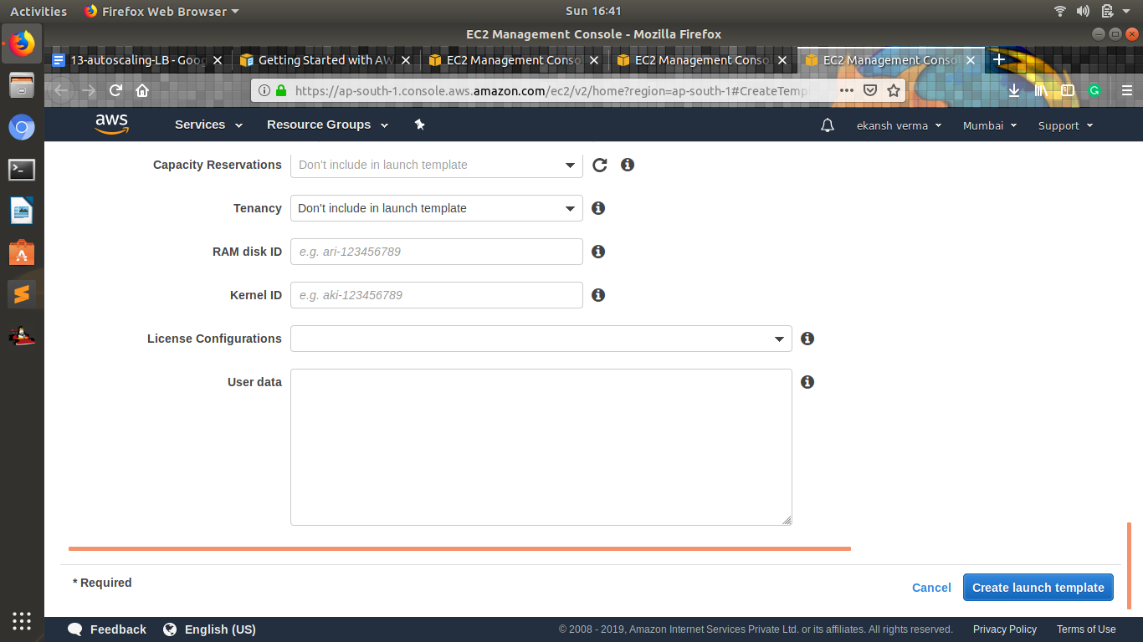

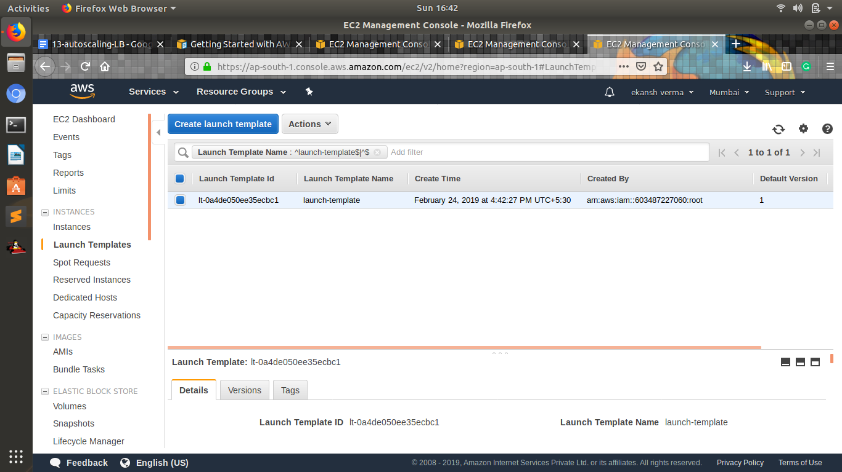

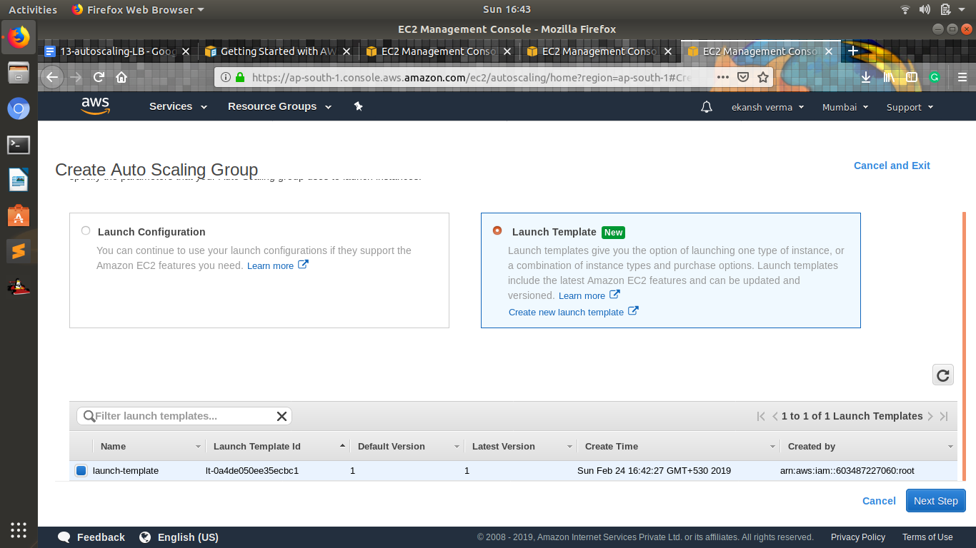

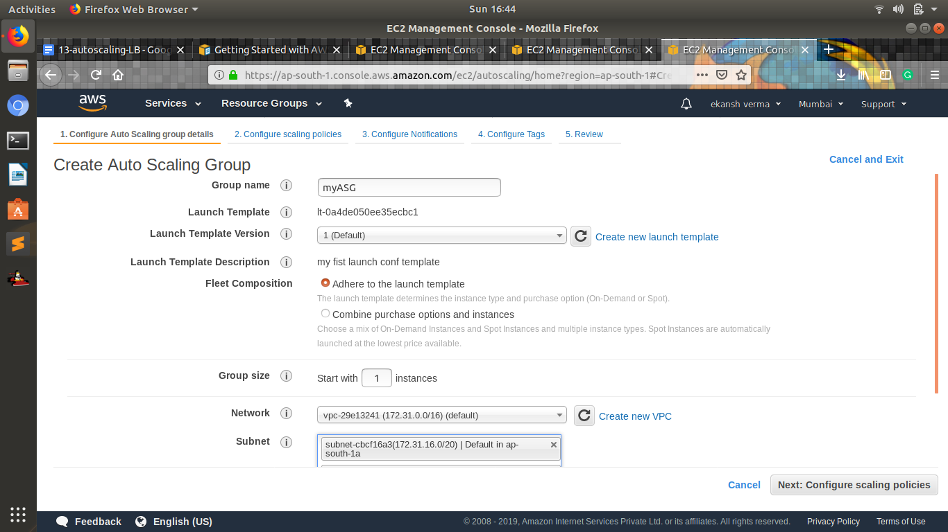

1. **Setup autoscaling Wordpress application with the Application load balancer. Auto-scaling should be triggered based on CPU usage of EC2 instances.**

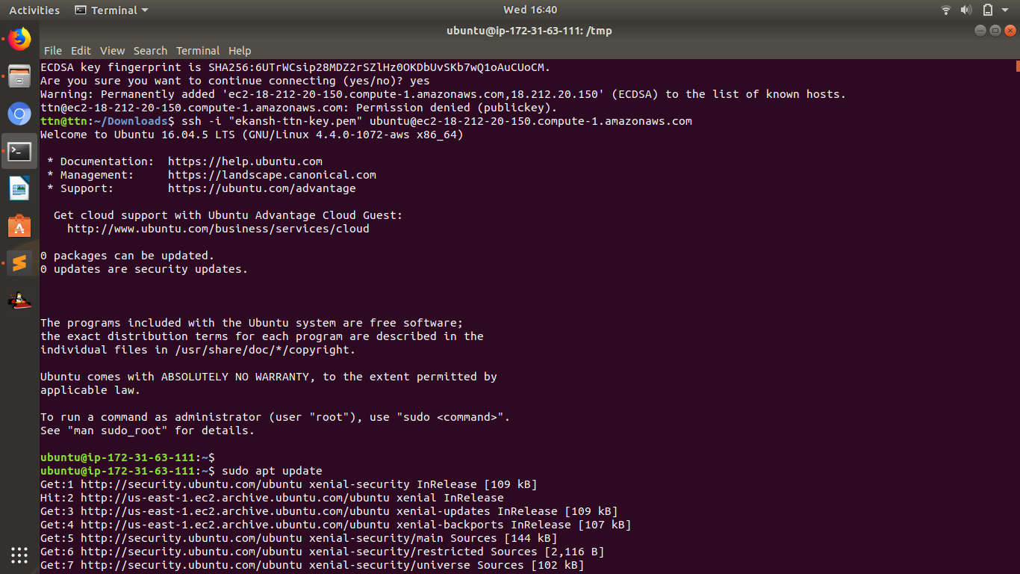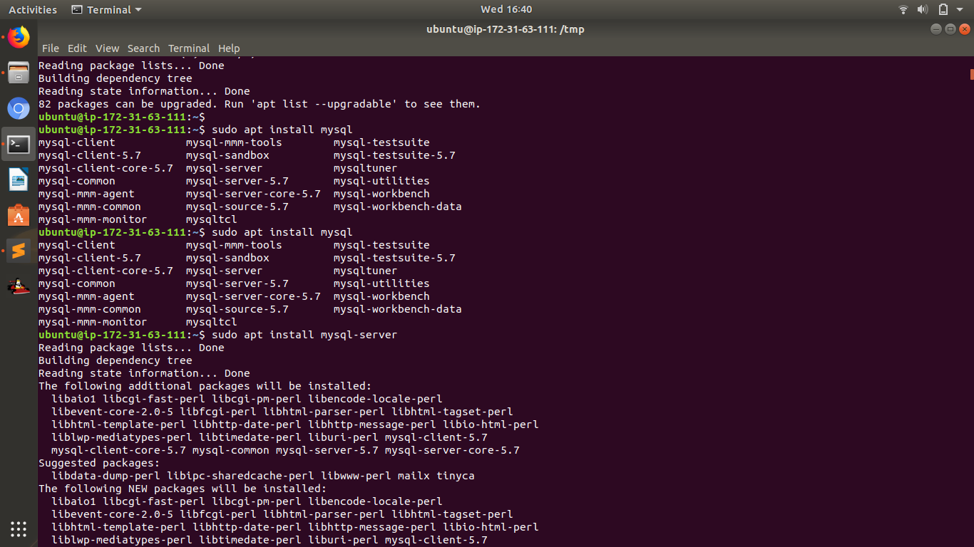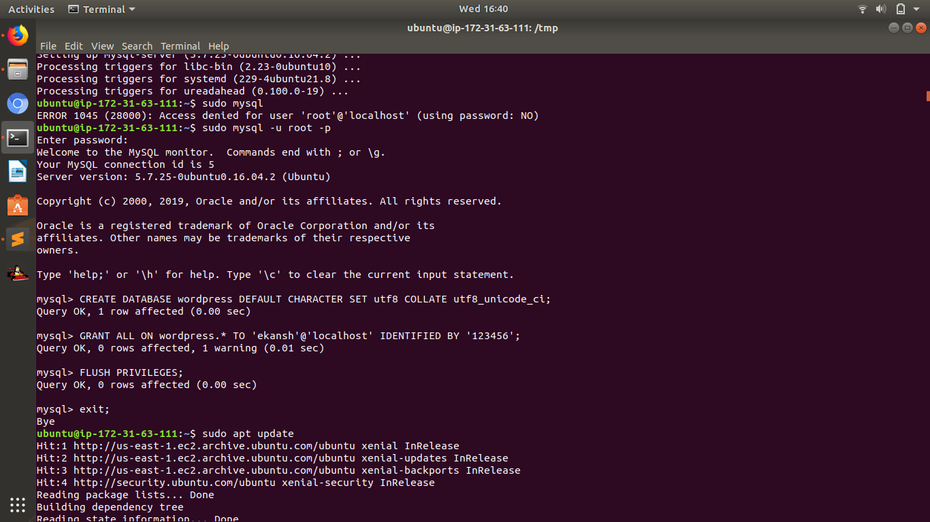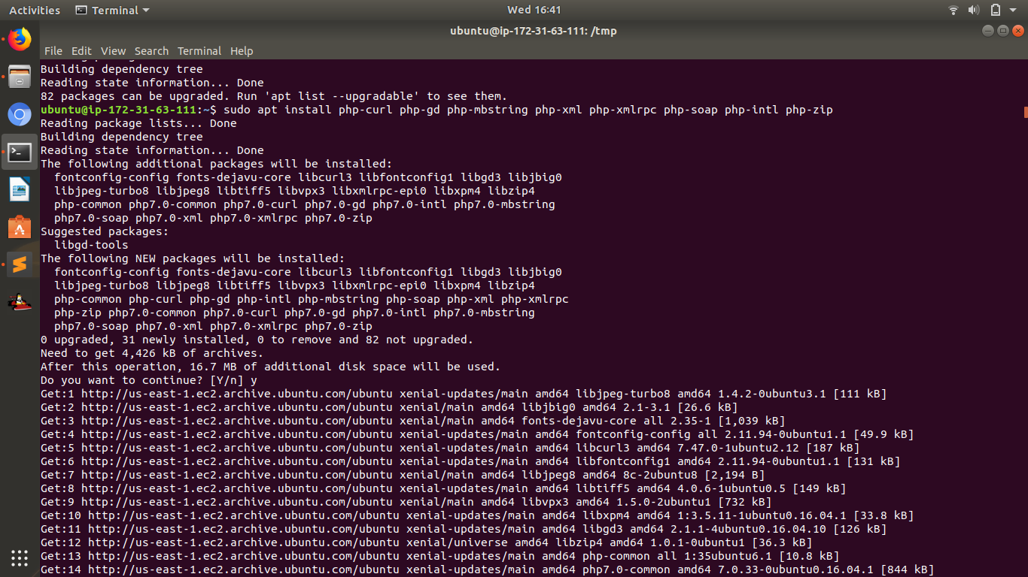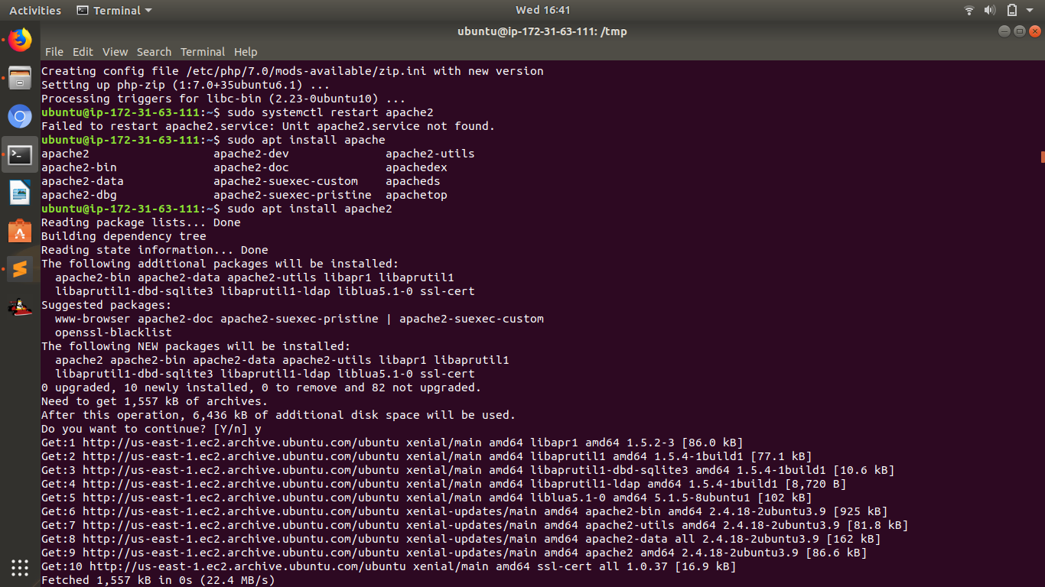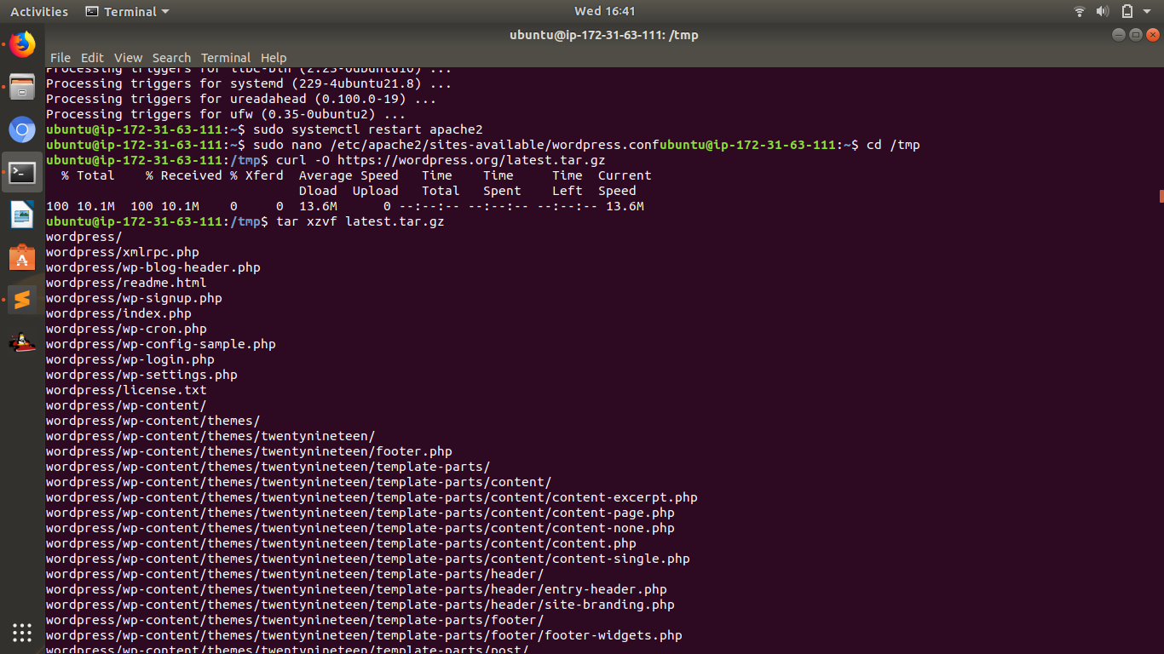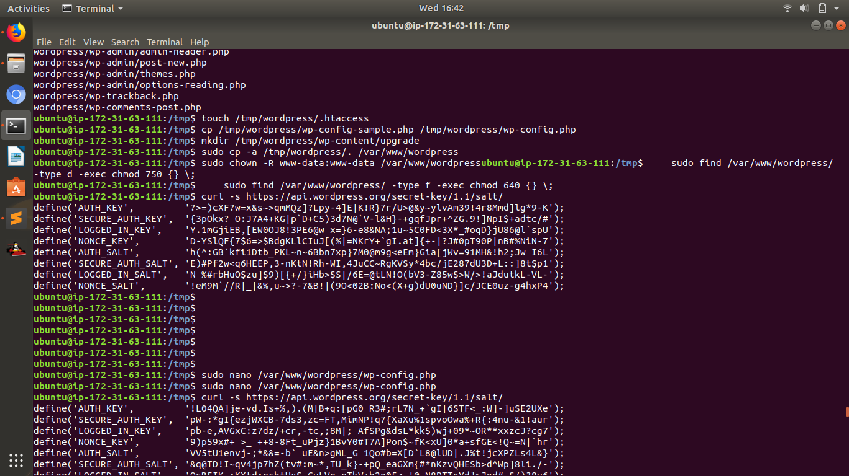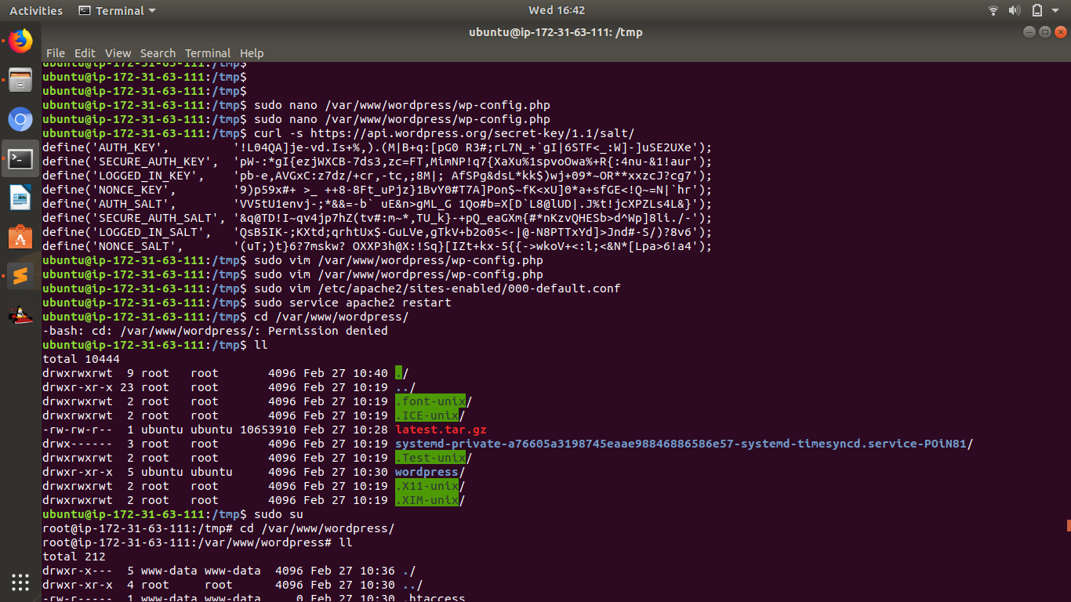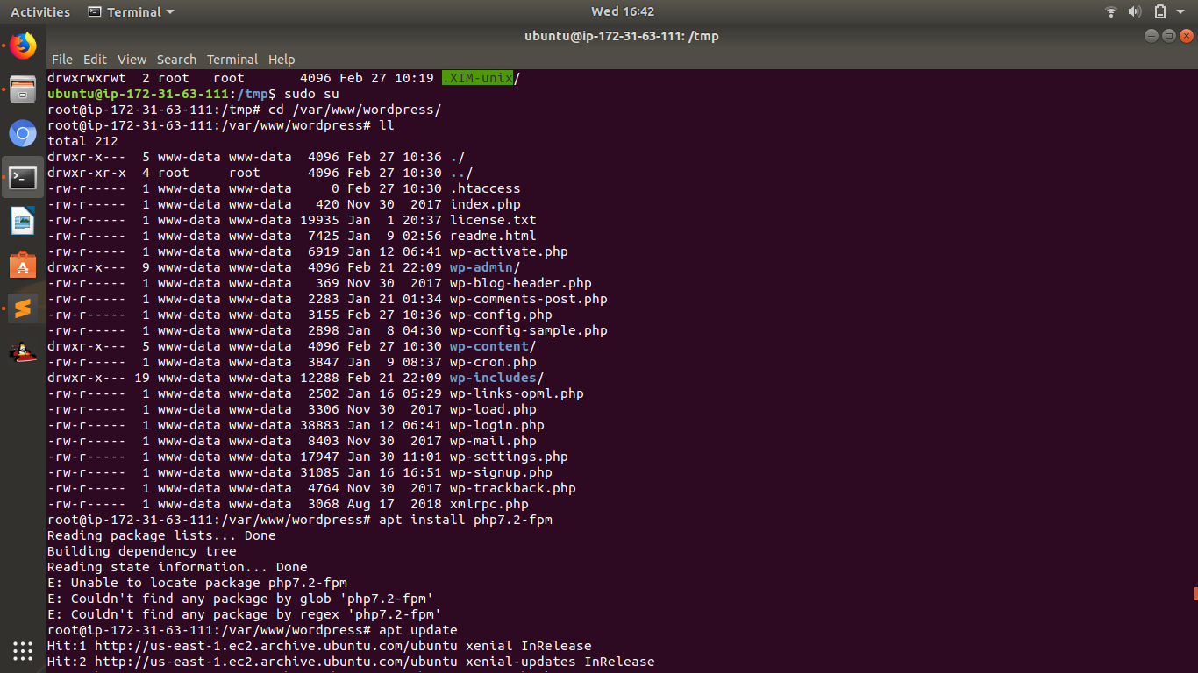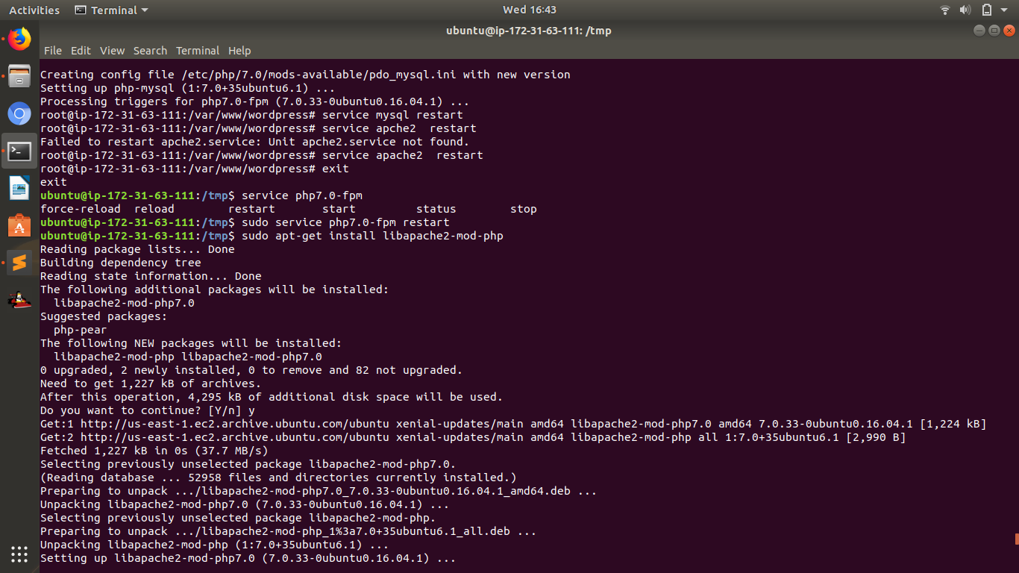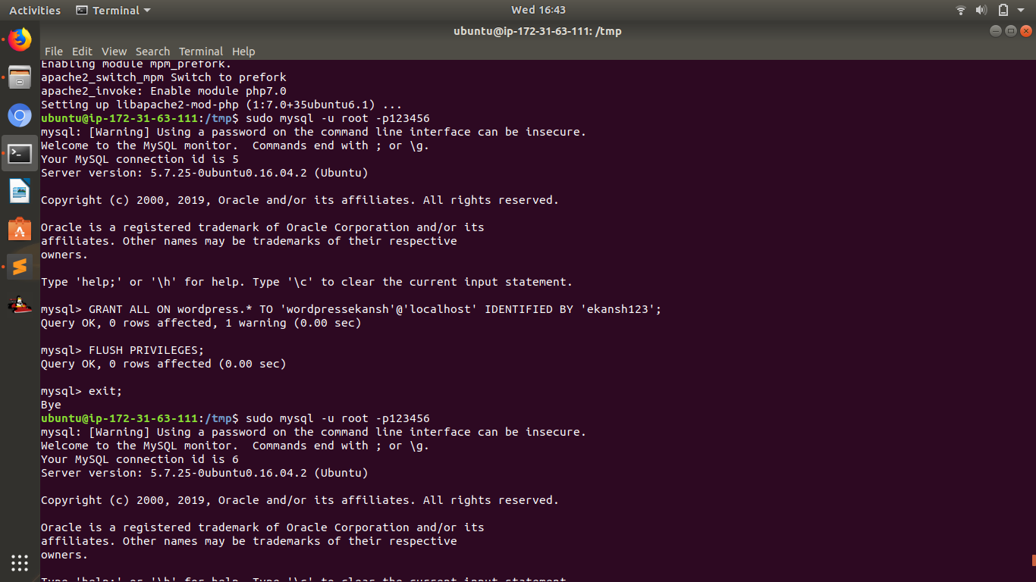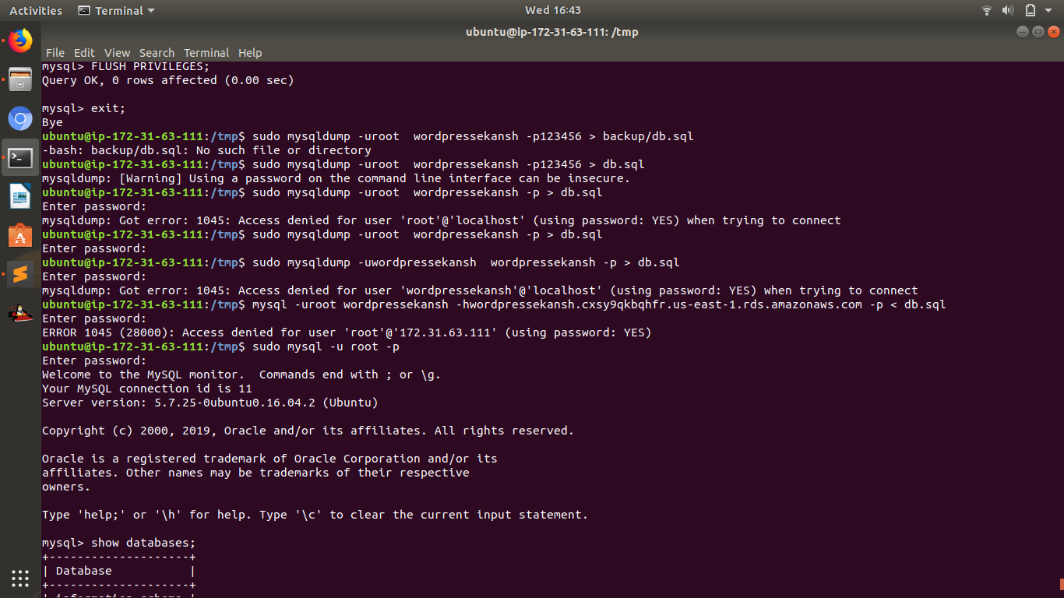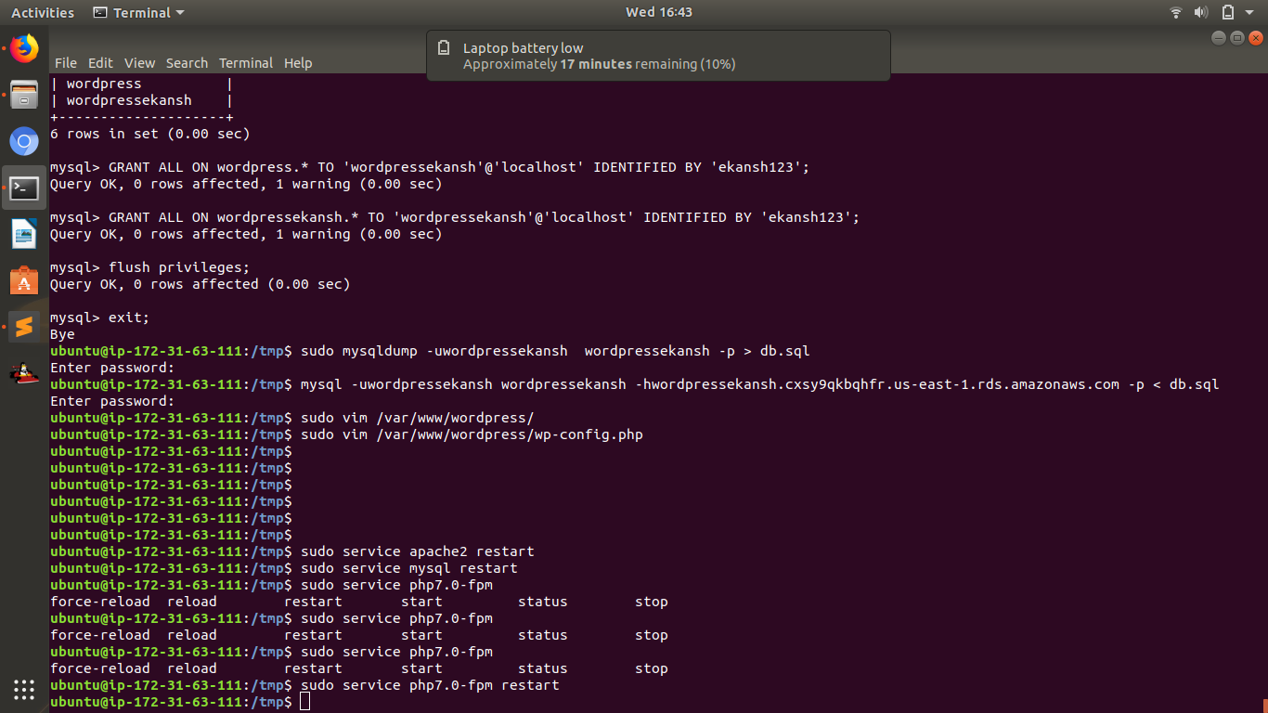

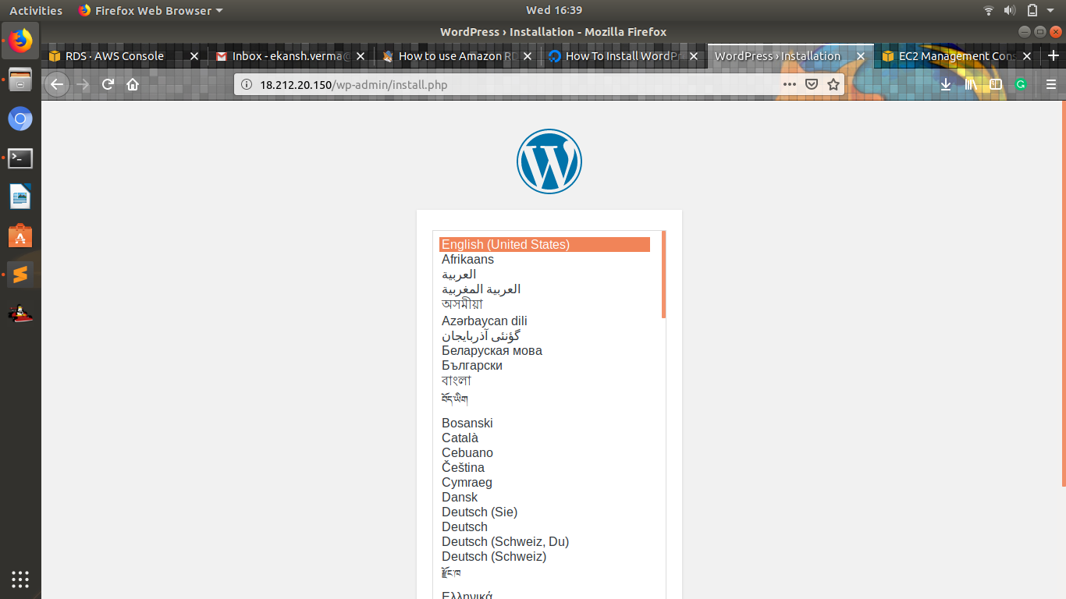

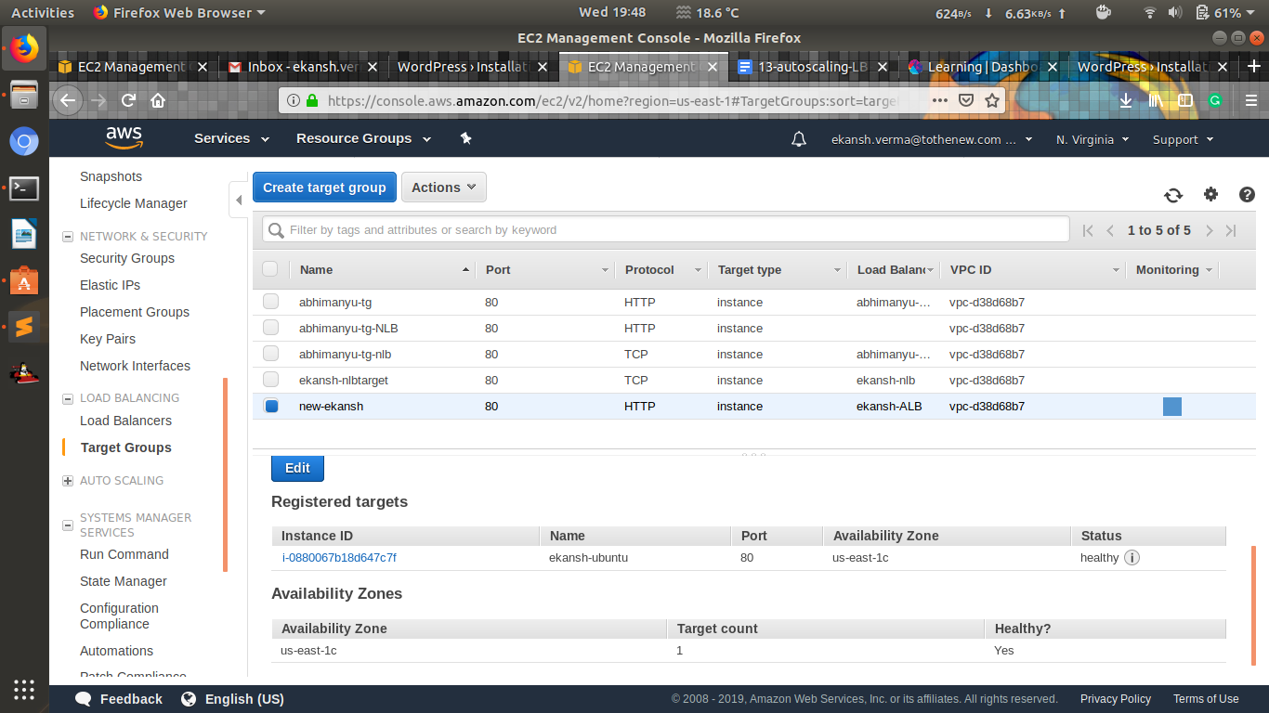

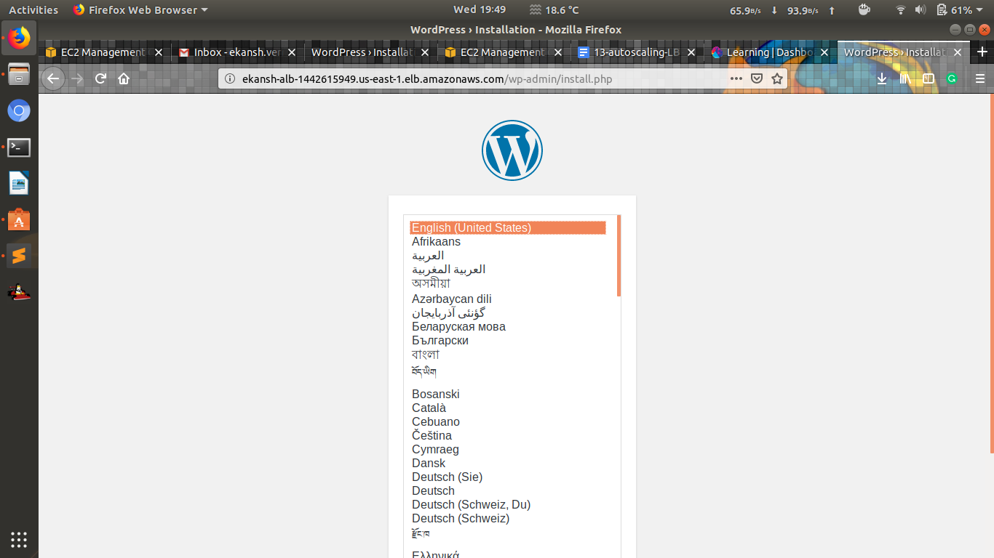

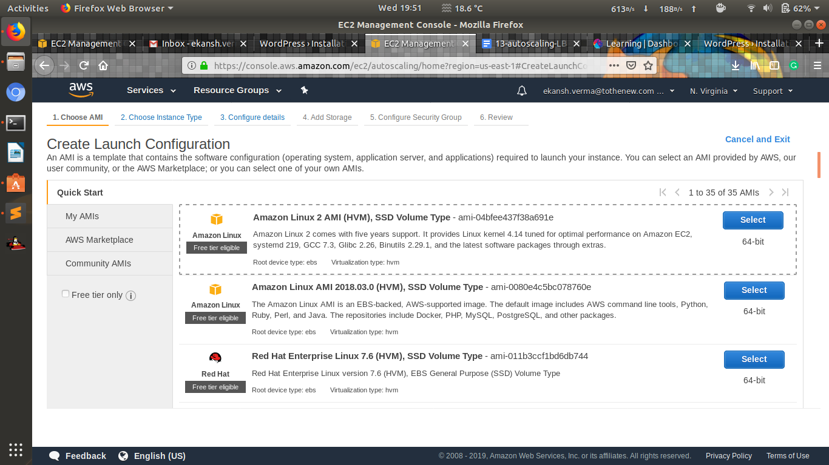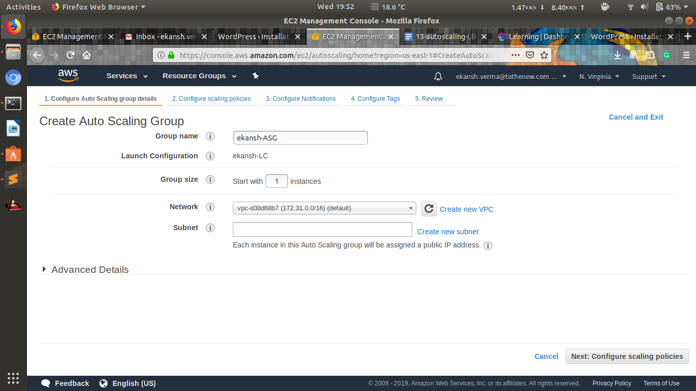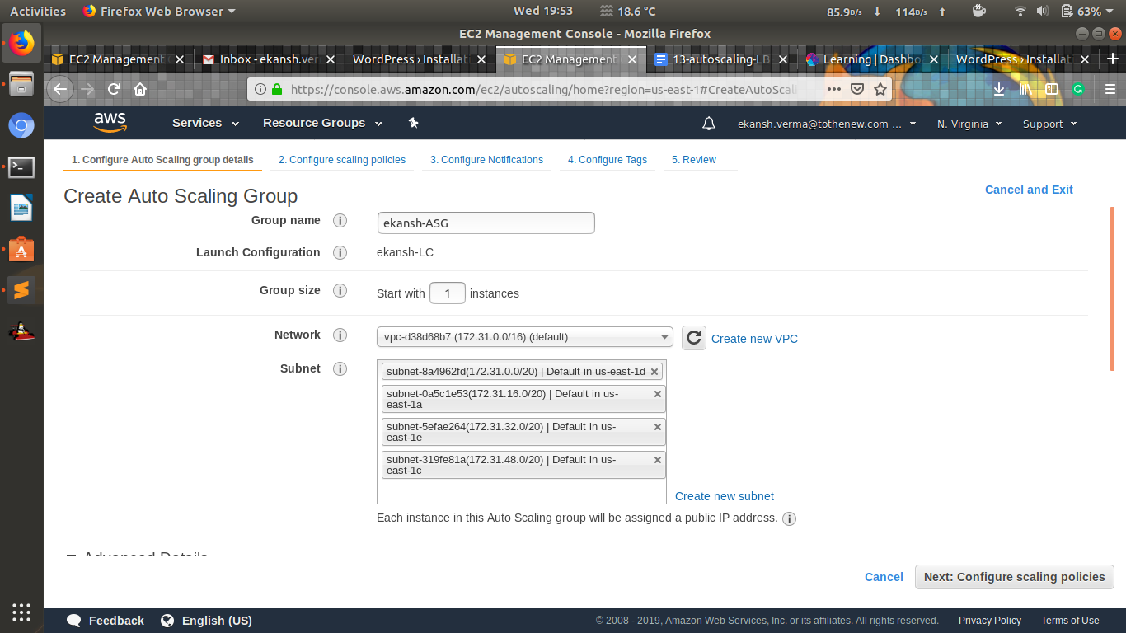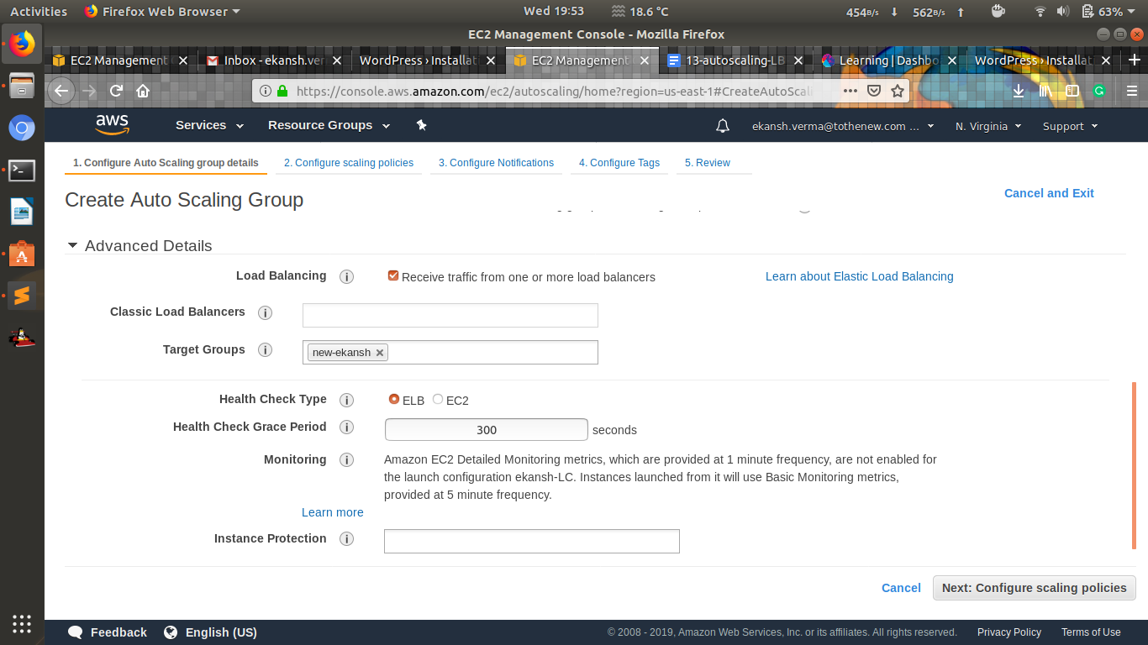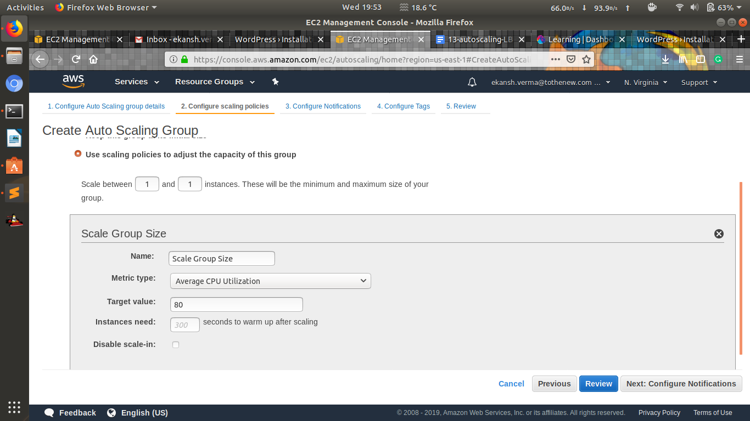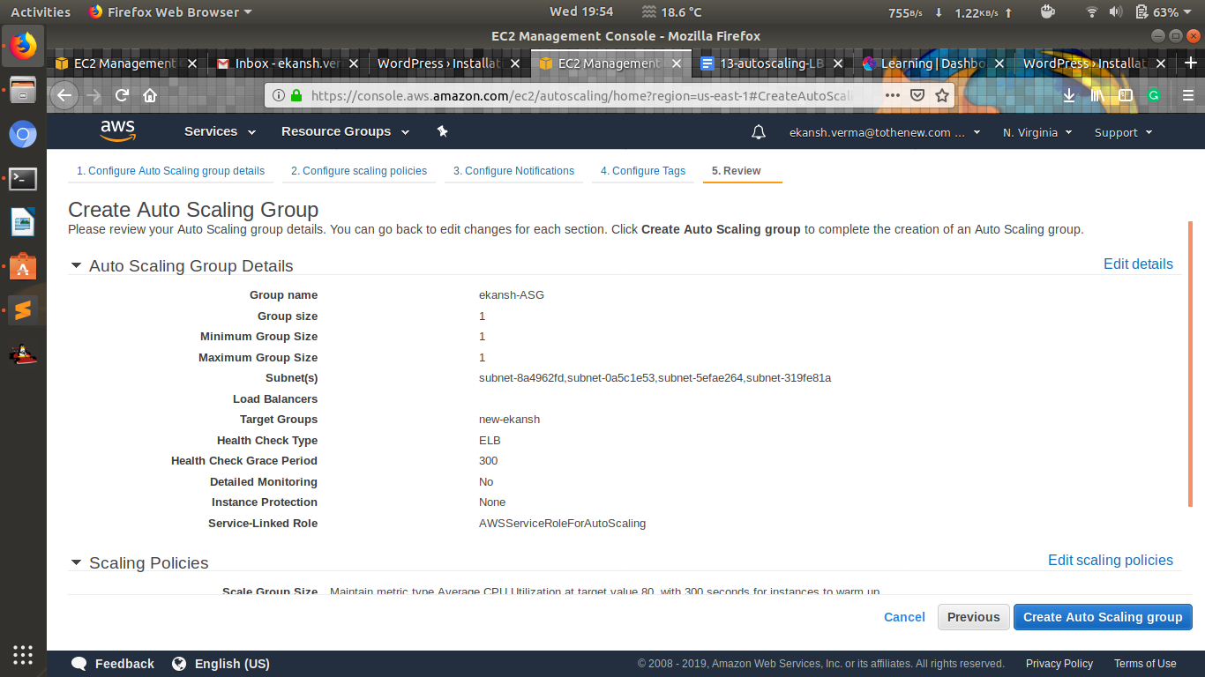

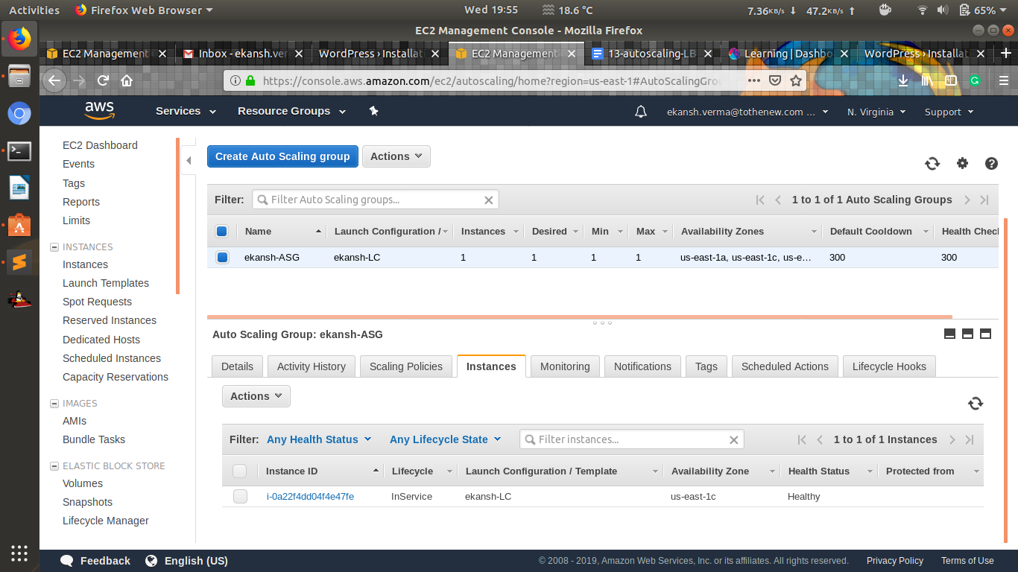

1. **Create another Wordpress website and use the ALB created above to send traffic to this website based on the hostname**

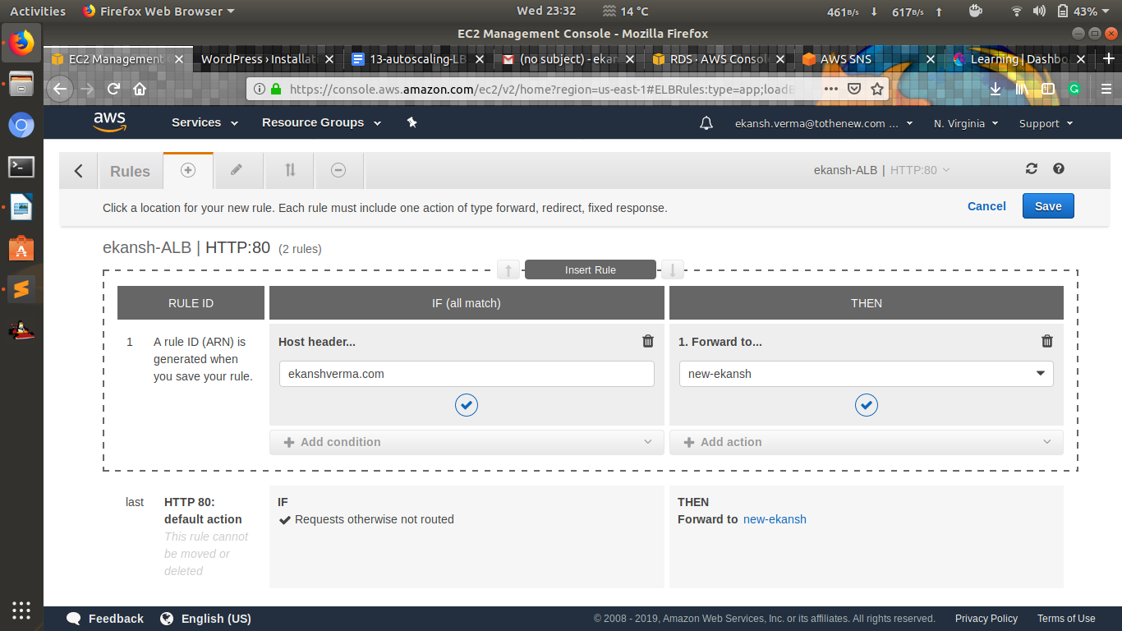

1. **Use NLB that replaces the ALB in the above setup.**

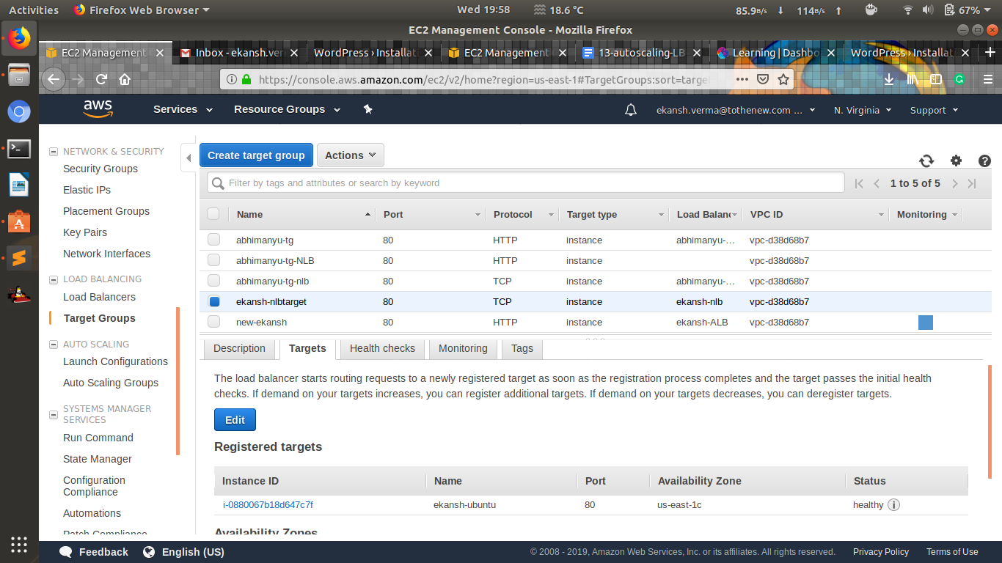

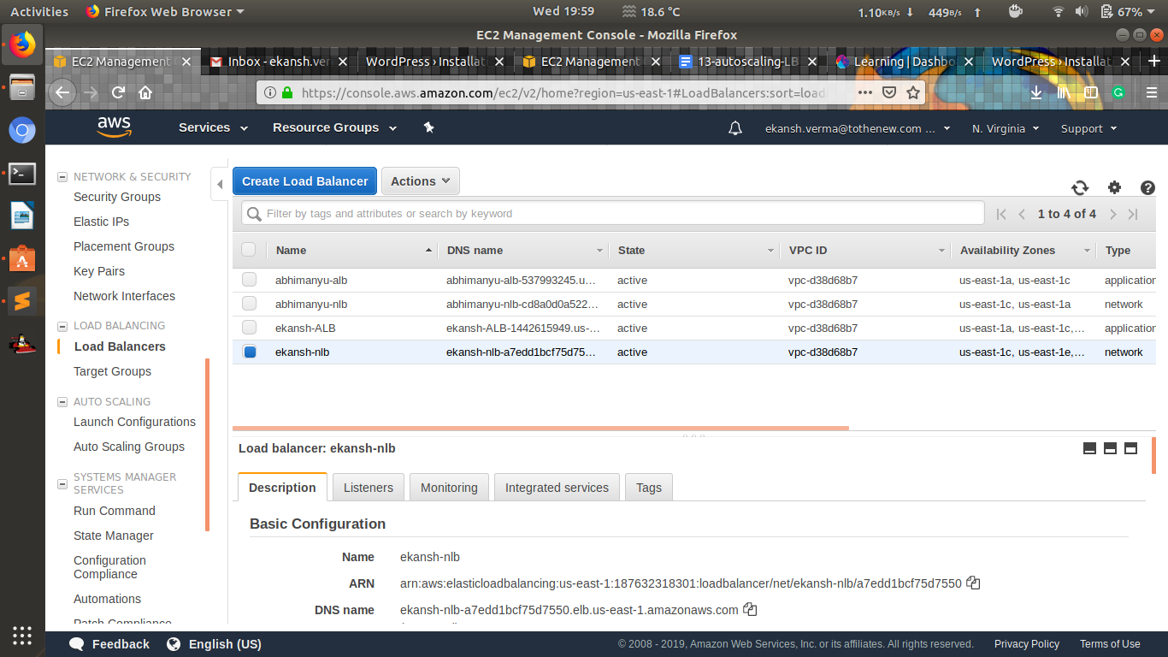

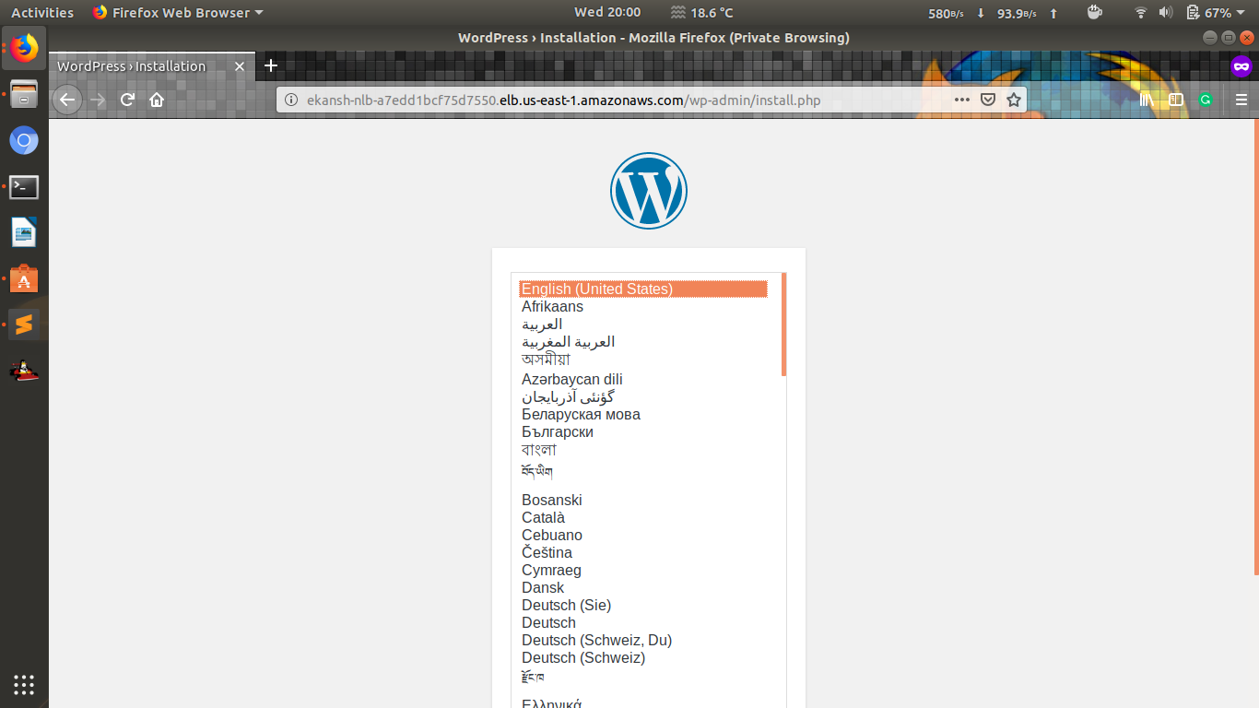

1. **Take an instance out of the ASG.**

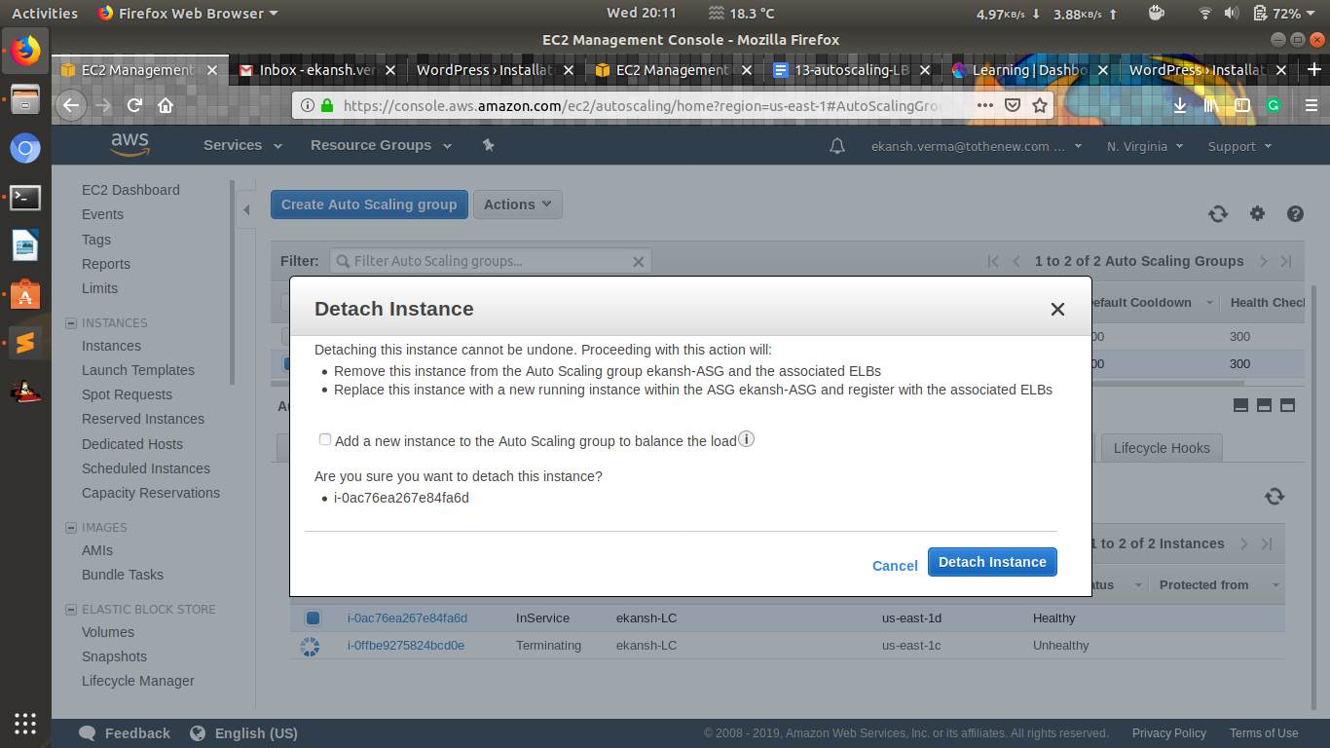

1. **Put scale-in protection on an instance in the ASG.**

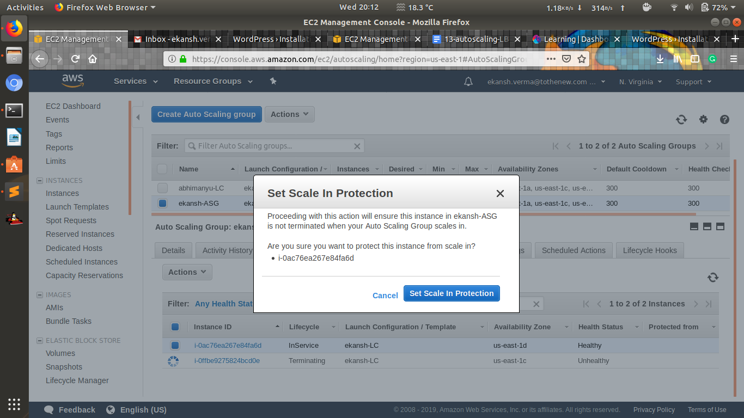

1. **Put Schedules in ASG to:** 
   1. **Remove all instances of the ASG at 8 PM**

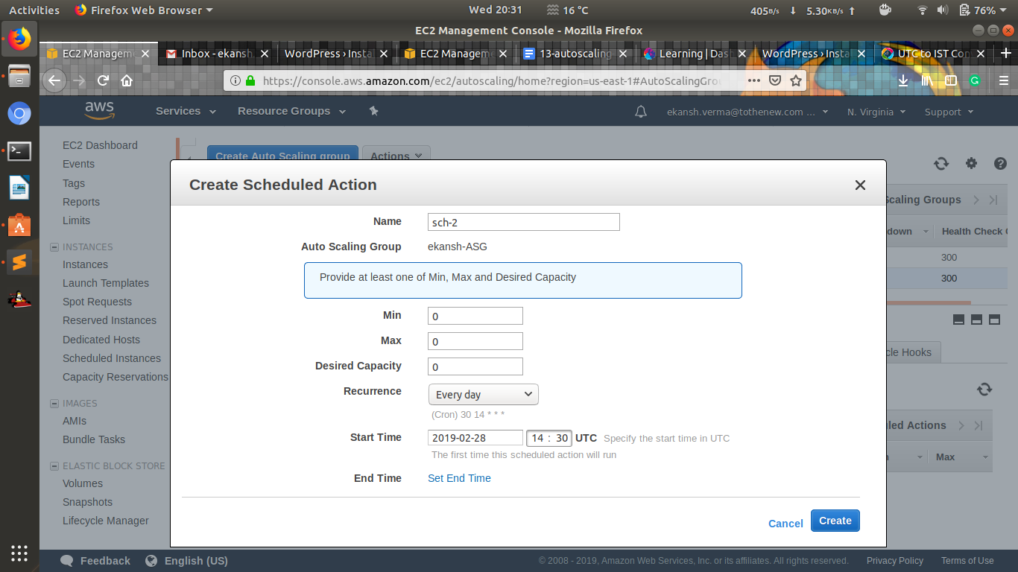

* 1. **Launch a minimum of 2 instances at 10 AM**

